# **Data Logging of Dht11 sensor - Esp32 with Thingspeak server**

Pushing DHT11 data to the Thingspeak server

Data= humidity and temperature of Environment sensed by DHT11 sensor

**Components required:**

* Esp32
* DHT11 sensor
* Jumper wires
* Thingspeak account
* Micro USB cable ( Type-B)

**Circuit Diagram:**

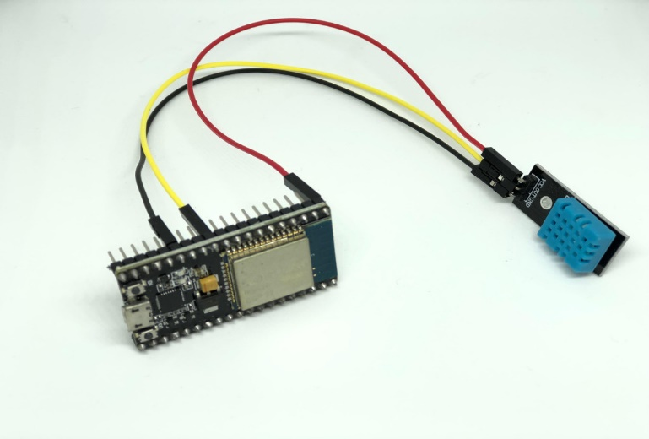

**Steps:**

**Step 1:**Create an account in Thingspeak server/platform.

Log in to the platform.

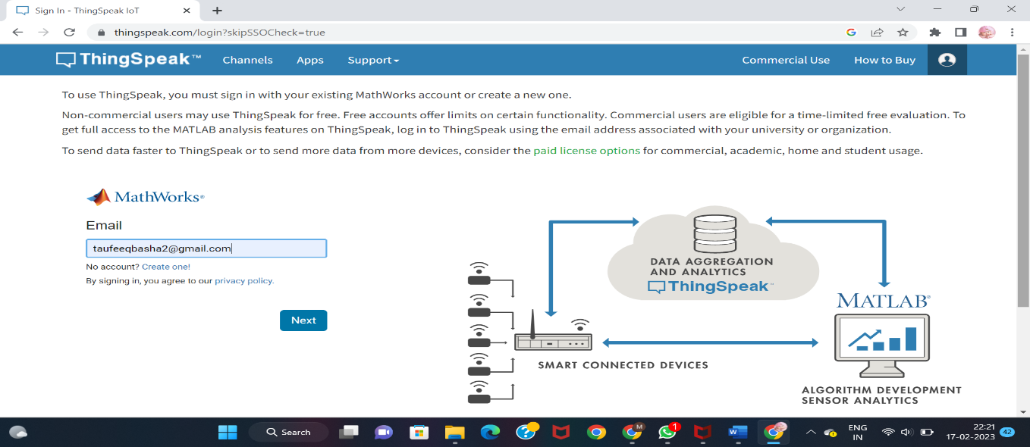

**Step 2:**Click on the new channel.

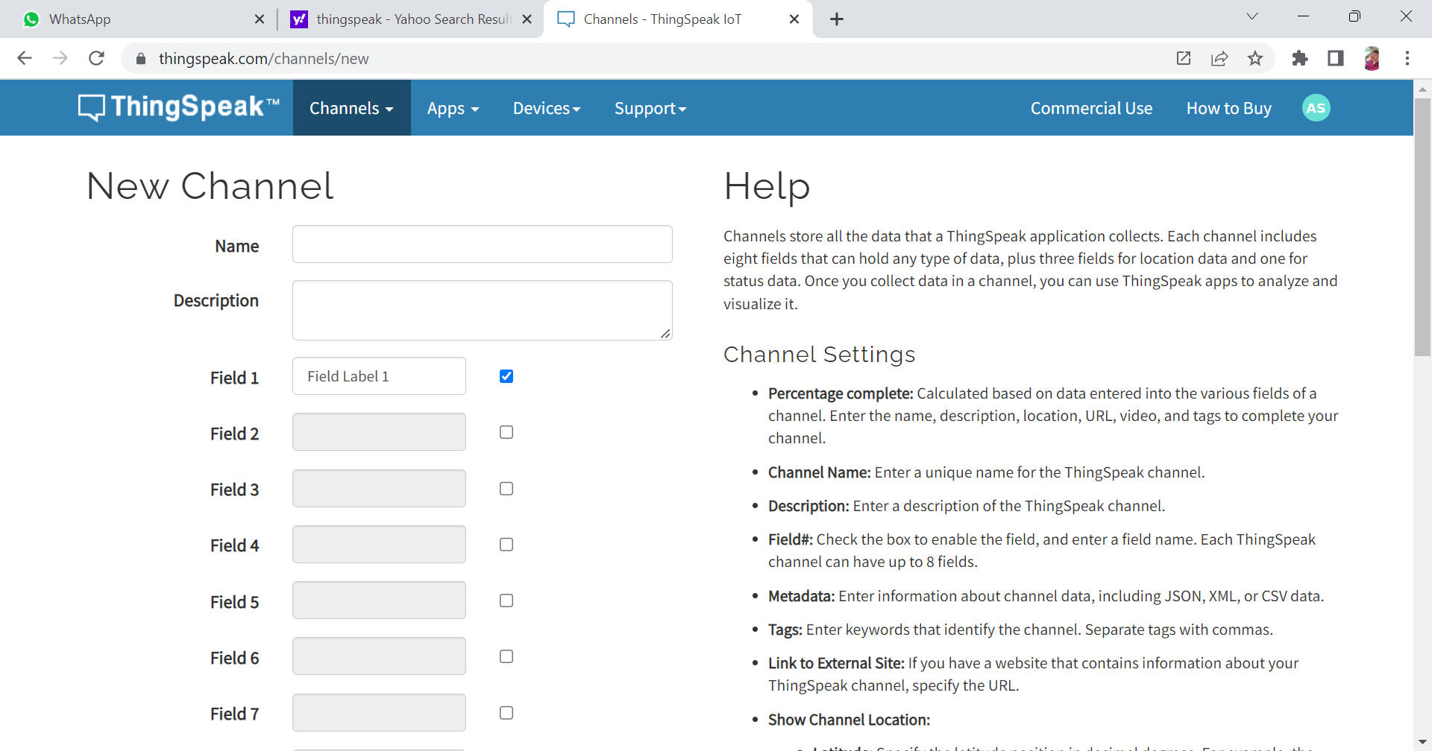

**Step 3:**Create a channel with 2 fields;

Field one = temperature

Field two = humidity

* You can see the fields as follows

**Step 4:**Go to API keys and copy the write/read key;

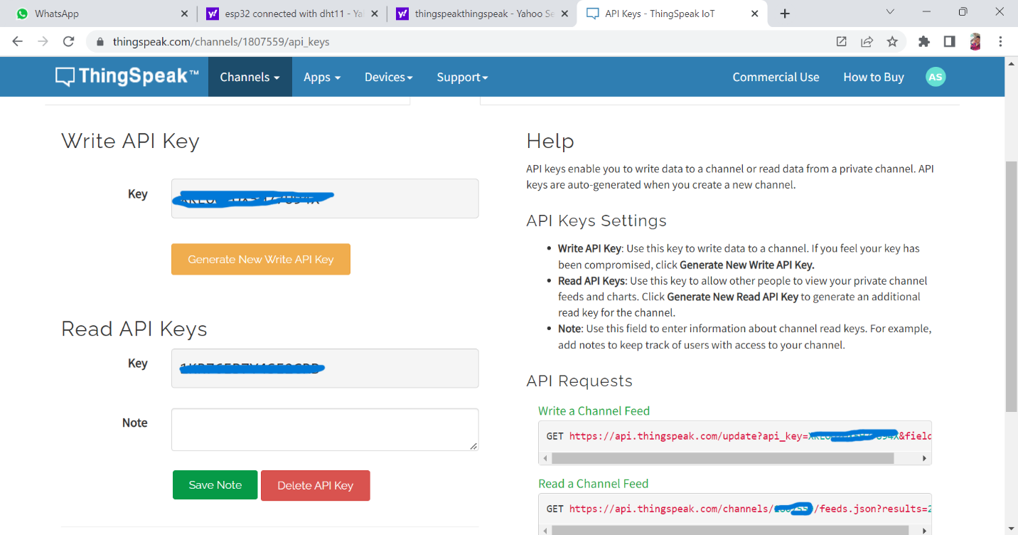

Write API key : to push the data for the environment to server

Read API key : to collect the data from the server.

We use these keys in the code to connect the thingspeak server and board.

**Step 5:**After that go to devices and select MQTT if you are using MQTT logic(pgm), create a device by the name dt11.

Next we will get client id , username, and password . use the in MQTT program.

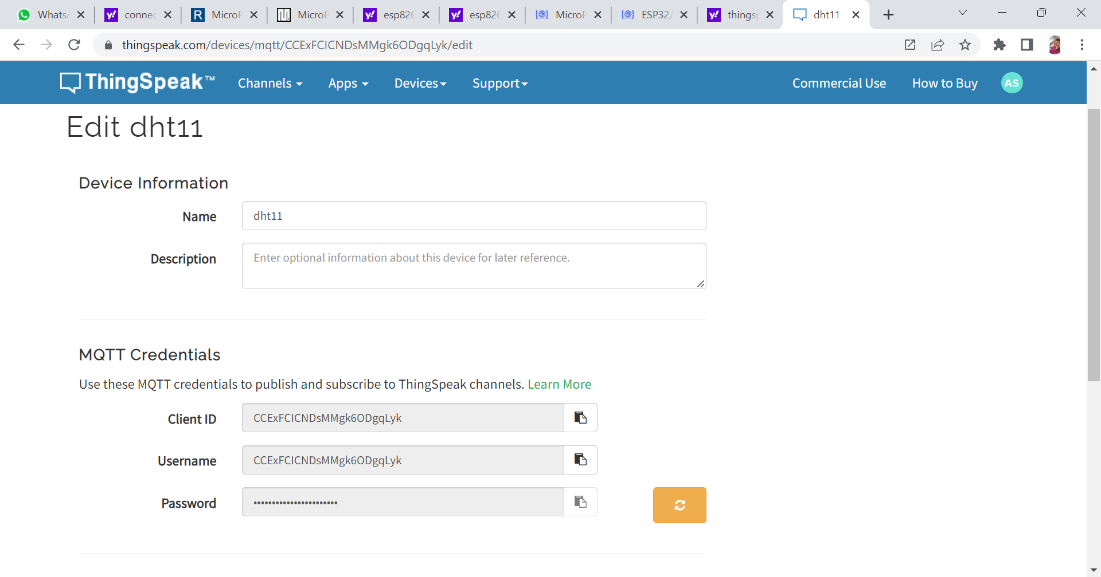

* The device of name dht11 is created.

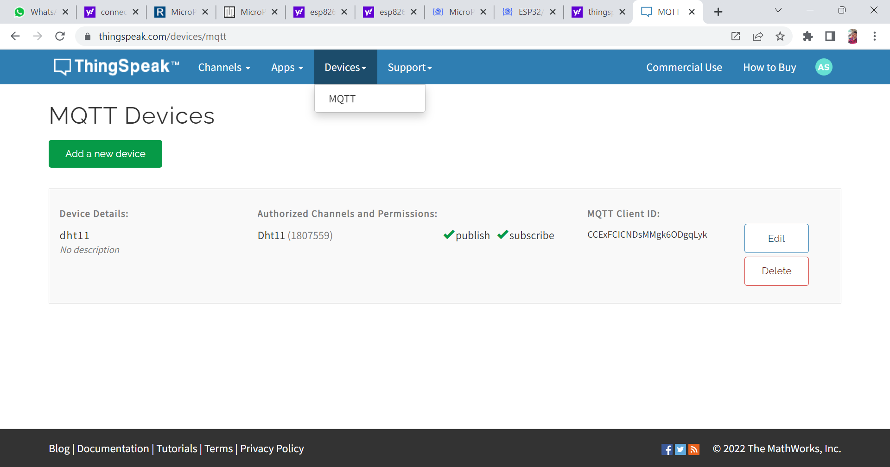

**Program:**

**Note: by using MQTT.**

Program is done in the mu editor / Thonny in python language.

from machine import Pin

from dht import DHT11

import network

from time import sleep

import sys

from umqtt.simple import MQTTClient

d = DHT11(Pin(15))

SSID = 'WiFi Name'

PASS = 'WiFi Password'

CLIENT_ID = 'ThingSpeak MQTT Client_ID'

SERVER = 'mqtt3.thingspeak.com'

USERNAME = 'ThingSpeak MQTT Username'

PASSWORD = 'ThingSpeak MQTT Password'

client = MQTTClient(client_id = CLIENT_ID,

                    server = SERVER,

                    user = USERNAME,

                    password = PASSWORD)

CHANNEL_ID = 'ThingSpeak Channel_ID'

topic = 'channels/' + CHANNEL_ID + '/publish'

topic = bytes(topic,'utf-8')

def dhtData():

    d.measure()

    t = d.temperature()

    h = d.humidity()

    return t,h

def connectWifi():

    wifi = network.WLAN(network.STA_IF)

    wifi.active(False)

    sleep(0.5)

    wifi.active(True)

    wifi.connect(SSID, PASS)

    sleep(2)

    if (wifi.isconnected()):

        print('Connected')

    else:

        print('Not Connected')

        sys.exit()

connectWifi()

try:

    client.connect()

except:

    print('Not Connected to MQTT Broker')

    sys.exit()

while True:

    temp, hum = dhtData()

    msg = '&field1={}&field2={}'.format(temp,hum)

    msg = bytes(msg, 'utf-8')

    client.publish(topic,msg)

    print('Temperature=',temp)

    print('Humidity=', hum)

    sleep(20)

**(OR)**

**Program:**

**Note: by using Request.**

Program is done in the mu editor / tonney in python language.

from machine import Pin

from dht import DHT11

import network

from time import sleep

import sys

import urequests

d = DHT11(Pin(15))

SSID = 'WiFi Name'

PASS = 'WiFi Password'

WRITE_API_KEY = 'Write_API_Key'

def dhtData():

    d.measure()

    t = d.temperature()

    h = d.humidity()

    return t,h

def connectWifi():

    wifi = network.WLAN(network.STA_IF)

    wifi.active(False)

    sleep(0.5)

    wifi.active(True)

    wifi.connect(SSID, PASS)

    sleep(2)

    if (wifi.isconnected()):

        print('Connected')

    else:

        print('Not Connected')

        sys.exit()

connectWifi()

while True:

    temp, hum = dhtData()

    data = '&field1={}&field2={}'.format(temp,hum)

    request = urequests.get('https://api.thingspeak.com/update?api_key=' + WRITE_API_KEY + data)

    request.close()

    print('Temperature=',temp)

    print('Humidity=', hum)

    sleep(20)

Output:

